**Project 4 test Plan**

Test #1 – Open Jar file

Expected result: Jar file opens, shows Gui, opens reservations.dat, displays all reservations in JList

Actual result – agrees

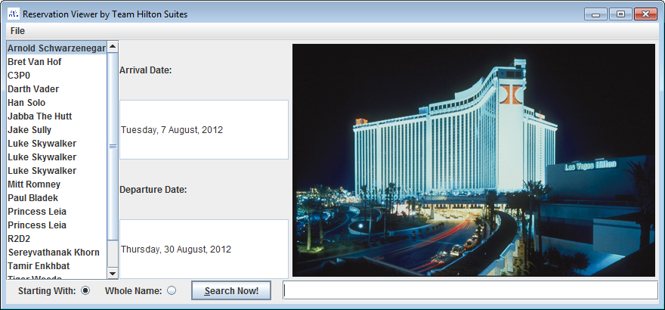

Test # 2 – Search is default button.

Expected result – search event fired by pressing enter

Actual result – agrees

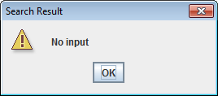

Test #3 – Scrolling through Jlist

Expected result - updates arrival date and departure date

Actual result- agrees

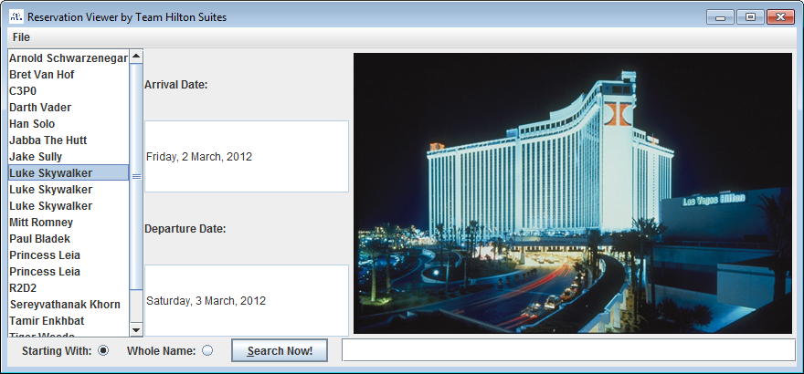

Test #4 – Search with starting with selected, with Han as input

Expected result- Han Solo selected on JList

Actual – agrees

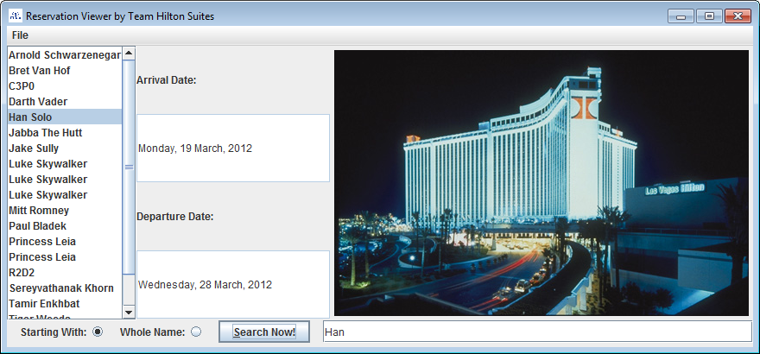

Test #5 – search with starting with selected, with z as input

Expected – no result found

Actual – agrees

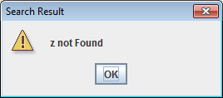

Test #6 – Search with Whole name, input luke skywalker

Expected- Luke Skywalker selected on Jlist

Actual – agrees

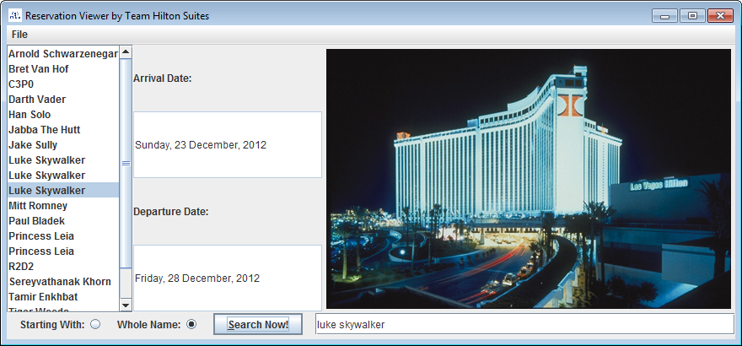

Test #7 – Search with Whole name, input luke skywalke

Expected – no result found

Actual - agrees

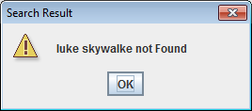

Test #8 – Opening a new binary file, good input

Expected – opens binary file; refreshes Jlist

Actual – agrees

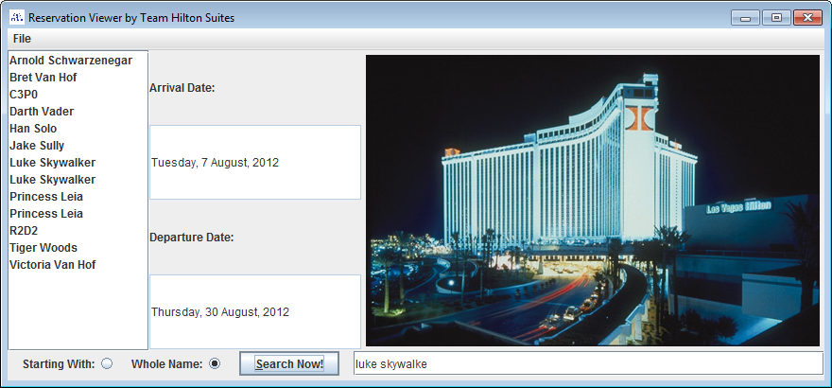

Test #9 – Open binary file, Bad input

Expected – refuses to open

Actual – Agrees

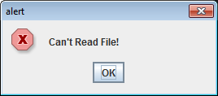

Test #10 – Close program menu item

Expected – program closes

Actual - agrees

Test#11 – Run a program without “reservations.dat” in directory

Expected – Pop up window, opens alternate database

Actual – agrees

